|  |  |
| --- | --- |
| **Logo**  Annual Report 2020/2021 | **انجمن افغانان لندن**  **Afghan association of london**  **(harrow)** |

# Acknowledgment

It will not be an exaggeration to say that 2020/2021 has been one of the most challenging year in the history of the Afghan Association as a charity. The Coronavirus epidemic has indeed affected the community profoundly. The Charity’s dedicated staff, and valued volunteers have responded to the crisis with vigour and dedication. We would like to extend our sincere thanks to everyone who has made a contribution towards our work. In particular, we would like to thank our current funders for their generous support of the Coronavirus Epidemic Emergency Response Project in Particular **the National Lottery Community Fund and Harrow Giving**. The project has made huge difference during the current crisis.

Our Supporters and Funders

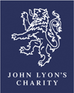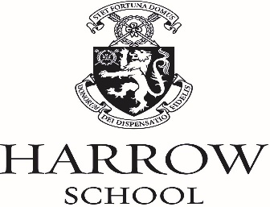

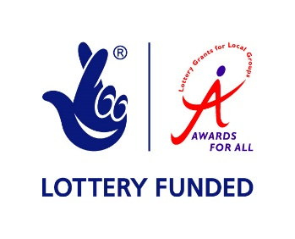





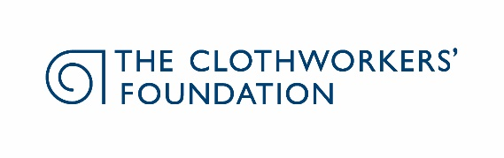

# 

# Table of Content Page:

**Message from the Cahir for the Year ended 31 March 2021 3**

**Objectives, structure, governance and management 4**

## Achievements and performance 4-9

## Reference and administrative information 9

## Pictures of Activities and Projects 10-11

# Message from the Chair for the year ended 31 March, 2021

I am delighted to introduce the 2020/2021 annual report. The external context for the Afghan Association’s work as a Charity has been highly challenging particularly in the face a major crisis as a result of Coronavirus epidemic. The Charity’s dedicated staff and volunteers have responded in a speedy fashion by establishing new projects to provide help and support to the most vulnerable members of the community. They have adapted quickly in such uncertain times and have responded by initiating a Coronavirus Epidemic Emergency Response Project. We have been successful in securing funding from different sources for different projects. The project has been a great success as illustrated in numerous positive feedback letters we have received from the members of the community, appreciating the Afghan Association’s response in the time of this unprecedented crisis. I would like to take this opportunity to thank our dedicated staff and valued volunteers and in particular the funders, whose support and generosity was essential in creating the Epidemic Emergency Response Project.

I want to thank the Board of Trustee colleagues for their support over the past year. The contribution they make to the charity is very much appreciated and valued enormously.

**Karim Shirin**

**Chair, Board of Trustees**

**Objectives, structure, governance and management**

The main objectives of the Charity are to:

1. To relieve poverty amongst the Afghan community in the NW London Boroughs, by the provision of an advice and interpreting service.
2. To advance education amongst the Afghan community in the same areas, particularly by the provision of language classes and a library.
3. To provide facilities for the recreation and other leisure-time activities for people who are in need of such facilities by reason of their social and economic circumstances with a view to improving their quality of life.
4. To assist the aged, particularly those from the Afghan community; and
5. To protect and preserve public health by the provision of advice.

Trustees are jointly the governing body and have ultimate responsibility for the operational administration of the Afghan Association, its premises, finances, and the employment of staff. The trustees may appoint co-opted members in order to bring specific skills and expertise to the charity.

## Key Achievements and Success

AAL is now running a number of projects and services over the last year.

Scientific evidence clearly shows, that COVID-19 does not affect all population groups equally. Many analyses have shown that older age, ethnicity, male sex and geographical area, for example, are associated with the risk of getting the infection, experiencing more severe symptoms and higher rates of death. The Public Health England review of disparities in the risk and outcomes of COVID-19 shows that there is an association between belonging to some ethnic groups and the likelihood of testing positive and dying with COVID-19. BME people in the UK have experienced years of systematic discrimination from government and in the workplace. The Afghan Association is well aware that our community are more likely to be living in overcrowded accommodation, less likely to have access to good healthcare, and more likely to be trapped in low-paid, high-risk jobs.

The Afghan Association has responded to the crisis immediately, by initiating the Coronavirus Epidemic Emergency Response Project. We have recruited sessional workers and a pool of impressive volunteers to provide practical support, information, befriending for isolated and vulnerable members of the community. More than 2000 community members have benefited from the Afghan Association’s services, in particular from provision of advice, information, practical support and befriending as part of the Emergency Project. We have enhanced our partnership and working relationship with key voluntary sector charities at a local and London-wide level. We have referred clients to Harrow Law Centre. HLC staff has been extremely helpful, providing an excellent service. We have been working and have established referral mechanisms with Pinner Medical Centre, GPs, Harrow Mencap, WDP Harrow, a charity providing drug and alcohol treatment and recovery just to name a few.

**What others have said about us**

**COVID-19 Vaccine Guidance**

We have shared and distributed COVID-19 vaccine guidance which has been translated into community languages. We have assisted the Harrow Council in producing a video on Coronavirus in Afghan languages which was widely shared with the community. **Thank you** for helping us spread the word about our new translated guidance and sharing on your social media channels. Together we can ensure language is no barrier to accessing COVID-19 vaccines. **Matteo Besana,** COVID-19 Advocacy Project Lead

**National Censes March 2021**

*On behalf of the Office for National Statistics, and as my role as a Census Engagement Manager for Barnet, we would like to thank the Afghan Association of London for the support they have provided in raising awareness and encouraging participation in Census 2021 among the Afghani Community.*

*Sami Aziz was our main contact person and he was instrumental in getting our messaging, on the importance and relevance of Census, out to the Afghan Community.*

*Once Census 2021 data is released, scheduled for early in 2022, we encourage the AAL to review the data that will be freely available on the ONS website. This data will show the location and the size of other Afghani nationals in England and Wales (for clarity NO personal information is released). This information will enable AAL to focus any outreach and support services in the right geographical areas.*

*So,* ***thank you*** *Afghan Association of London for your support. It was vital to the success of Census 2021 and will make a difference, not only to your Community but society in general.*

**Stephen Pal | Census Engagement Manager, Barnet South West |**

**Office for National Statistics |**

The vaccination rollout is going really well in Harrow and across the country and I want to thank you again for everything you're doing to try to help us break the chain of infection, protect our loved ones and help the NHS

**Cllr Graham Henson, Leader of Harrow Council**

I wanted to express how proud and appreciative I am of the recent efforts of AAL in supporting the Afghan diaspora during the COVID-19 pandemic. In a time where people are most in need of help, the Association has stepped up and been a point of call and assistance for the most vulnerable in our community. It has been encouraging to see your projects and successes through your social media, as well as through first-hand accounts of people you have helped directly. I am most impressed by the leadership and teamwork exhibited by the members, who I know make all of this possible.

**Thank you**

**Mr S**

I would like to thank the AAL for all their help and support during the COVID-19 pandemic. They have not only helped me but also others in the community, and I wanted to extend great appreciation to everyone at AAL for all that they have done. The Afghan Association has been a point of contact and assistance for the most vulnerable members of the community.  **Thank you.**

**Mr H**

I would like to take this opportunity to say a **Big Thank You** to Afghan Association of London for the ongoing support my family and I have received during the Coronavirus Pandemic.

Keep up the good work,

**Mr S H**

## Volunteering

The Afghan Association has benefited tremendously from the volunteering project in a number of ways: increased activity for the charity; increased variety of services, creating new projects, reaching out to more users. Volunteering is now an integral part of the Afghan Association’s service delivery. During the epidemic, our volunteers have contributed tremendously to the Afghan Association’s Coronavirus Emergency Project, providing essential support to the most vulnerable members of the community. We would like to take this opportunity to say thank you to all our hard working and dedicated volunteers.

**A Big Thank You to all our volunteers**

**Debating Club for Afghan Children**

After successfully establishing a debating club for Afghan youth, Dunya Amini, one of our valued volunteers has delivered two very productive online sessions with the Afghan youth during the lockdown under the title of **University and the Year Ahead**. The main purpose of these sessions was to encourage young people to utilise their time effectively in order to prepare themselves for future challenges. These sessions will assist the Afghan youth to overcome isolation during the lockdown and to broaden their social network in a positive way. “Volunteering with the Afghan Association has helped me to enhance my communication and social skills considerably. Setting up a debating society for Afghan youth was one of the best projects that I have initiated and delivered. The project has helped to spark discussions and encouraged critical thinking. Volunteering has indeed helped me to secure paid employment”. **Dunya Amini**

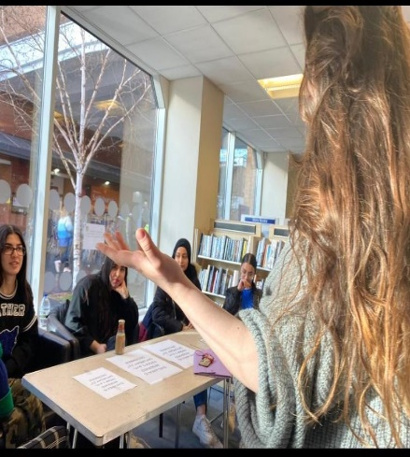 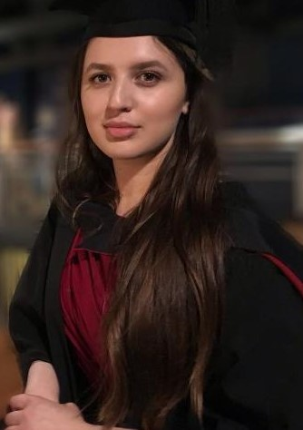 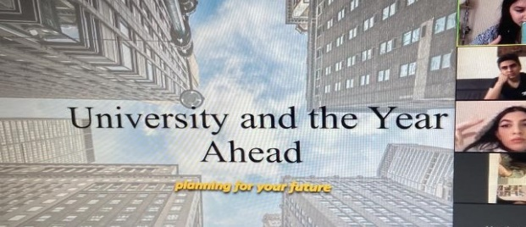

**Dunya Amini**

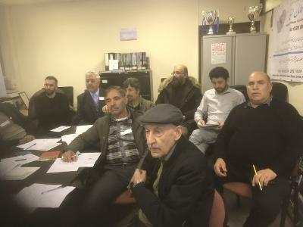

## Youth and Sport Activity

We are grateful to **John Lyon’s Charity and Harrow Young Foundation** for funding the Afghan Association’s Youth and Sport activities. **All youth & Sport activities will be resumed as soon as the lockdown is lifted.**

The Afghan youth are vulnerable and experience isolation and exclusion from different aspects of social life. They are affected by the lack of support, resources (sport and leisure facilities) and support networks. Many young people have difficulties settling into educational institutions and consequently fail to do as well at their studies. They, therefore, have limited employment opportunities and as a result may adopt a pessimistic outlook to life. In addition, young people are dealing with a range of issues such as lack of UK qualifications, lack of work experience, low self-esteem and confidence, little motivation or aspiration and a lack of positive role models. AAL facilitates different youth and sport activities.

### Football, Taekwondo, Volleyball (After School curricular activities)

Football is one of the most popular sports amongst the Afghan community. We have assisted four football managers to participate and successfully complete a coaching qualification. The feedback from participating teams is extremely positive. We would like to thank the John Lyon Charity for their generous funding and support which has enabled the Afghan Association to organise such a successful event annually for the last three years.

In order to facilitate cross-cultural understanding, the Association was keen to have an inclusive approach, and draw people together, across boundaries to enjoy football. In addition, sport and football in particular, have provided an attractive distraction from negative influences. Interacting with young people from mainstream and other communities has create a perfect platform for cross-cultural communication and acceptance of differences and the importance of universal values of respect and tolerance.

John Lyon’s Charity’s funding has enabled the Afghan Association to establish a Taekwondo Club in Harrow aimed at Afghan teenagers and young adults. The Taekwondo club is one of the most successful projects in Harrow, providing excellent opportunities for 50 young people to keep fit and healthy, overcome isolation by making new friends and having fun.

All youth and sport activities will be resumed as soon as the lockdown is lifted.

### Elderly Project

As part of the Coronavirus Epidemic Emergency Response Project, we have created a social group to ensure the most vulnerable members of the community overcome isolation. We have assisted two elderly people to use WhatsApp for the first time. “It is fantastic to be in touch with my friends and family in such a difficult time”. “So, thank you very much”. Mr M

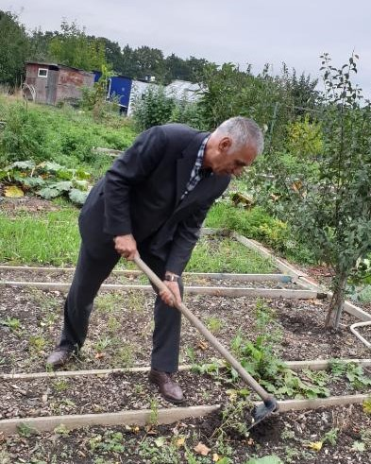 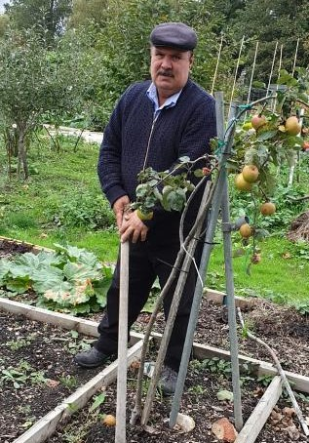 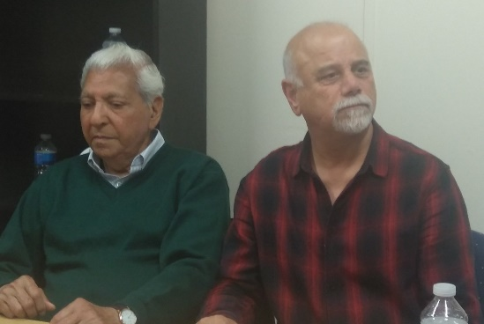

**Chess Club and Chess Competition**

We will resume the Chess Club as soon as the lockdown is lifted. The Chess Club meets every Monday 18:30-22:00. The Chess Club is becoming one of the most popular activities in Harrow.

### The benefits of volunteering:

While the volunteers bring a lot to different services, activities and projects, it is important to highlight that they have also benefited further from their volunteering experience – by helping to learn new skills, maintain and expand skills, knowledge and social networks.

### Over 40s Football

During the lockdown period, all activities were on hold. The over 40s Football team is becoming very popular with new members joining every week. The feedback from participants has been very encouraging.

We very much appreciate all the help given by our volunteers which has made such a difference to the lives of our community members. **Thank you**

# 

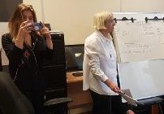

## Reference and administrative information

### Statement of trustee’s responsibility

The Trustees are responsible for preparing the Annual Report and the financial statements in accordance with applicable law. The Trustees prepare financial statements that provide a true and fair view of the state of affairs of the Charity, the incoming resources and application of resources including the income and expenditure of the Charity for the year.

The Trustees are responsible for keeping proper accounting records that disclose with reasonable accuracy at any time the financial position of the Charity and enable them to ensure that the financial statements comply with the Charities Act 2011, the Charity (Accounts and Reports) regulations and the provisions of the trust deed. They are also responsible for safeguarding the assets of the Charity and hence for taking reasonable steps for the prevention and detection of fraud and other irregularities.

### Financial Statement

The Board of Trustees are pleased that AAL has finished the year in a relatively stable financial position. AAL has secured additional funding from Awards for All for the elderly project and overhead costs respectively. However, in the absence of core funding to cover the main operational costs of the charity, it will be a challenge to sustain the current level of activities and services. We will continue with our search for additional sources of funding.

### Declaration by the Trustees

This report has been prepared in accordance with the Charities Law

By order of the Trustees:

**Signed: Karim Shirin Date: 25 May 2021**

**Name: Karim Shirin**

**Pictures of activities and projects**

|  |  |  |
| --- | --- | --- |
|  |  |  |
|  |  |  |

